## Merchant: Respondology

Demo date: Jun 5,, 2024  
Scoping start date: Jun 5, 2024

MSA Signature Date: Jul 8, 2024  
Onboarding Kick Off Date: Jul 9, 2024

[If Exists] Opt Out Date: Opt out by 9/1/24 if we are not SOC Type 1 compliant. Opt out 1/1/25 if not SOC Type 2 compliant  
Go Live Date: Aug 1, 2024

GTM POC: Nick  
Implementation POC: Ariel

ERP: QBO

Tax Integration: QBO Hard Coded Taxes - Need to confirm this

### 

### Key people at Merchant

### Accountant: Izzy Murdy, CFO

### CFO: Izzy Murdy, CFO

### Customer service rep who is really involved: Erik Swain, CEO

* Account Receivable POC: Stacy Heffner, Bookkeeping
* Billing POC: Stacy Heffner, Bookkeeping

### etc.

### Company summary

Respondology helps brands, athletes, influencers, and celebrities cleanse the hate in their social comment streams and engage more with their fans, promoting the use of technology for good with a goal of hiding toxicity from social media.

Moderators are core to this vision as they moderate comments that allude the filtering tech. Our social media Moderators are creating a healthy social experience unlike any other while earning side cash.

Goals (North star)

What is the merchant's goal? What pain are we solving? Why are they buying Tabs?

Raising their Series B and doubling in size by the end of 2024. Have 100 clients today (mostly enterprises) that have a bunch of parent/child relationships for billing. Currently a manual process that takes ~5 hours a week. Izzy and her Accountant Stacy are outsourced finance team.  
  
Is there an opt out clause? If so, what is the merchant looking for so that they don’t feel the need to exercise it?

Need SOC 2 Type 1 by September 1st. Need SOC 2 Type 2 by the end of 2024. Only way to get sign off from chief compliance officer  
  
AE Notes

Any important relationship information  
  
1) What is Merchant Temperament?

Great relationship with Izzy. Ali and I went out to dinner with her. Have not met the CEO, Erik.  
2) Is there key POC the buyer/decision maker?

Izzy is main POC and decision maker. Erik is contract signer/buyer  
3) What are the Tabs features the key POC care about?

QBO integration, contract management, invoice scheduling, Cash forecasting, Reporting in general

### Billing model

* Info on how merchant bills
  + Mostly monthly and quarterly. Some annual. Flat SAAS fees
* How contract is broken up
  + Annual, simple billing
* One off things to know about merchant
  + Nothing too complicated - Raising a Series B and growing fast

### Billing model

* Mostly flat SaaS fees
* Some Suage - implement in Phase 2
* Are the unique things about the customer creation process for this merchant?
  + Contract with enterprises and need to bill their child entities

### Contract Processing Steps

1. Steps to process
   1. Sometimes MSA/Order forms will be separate documents
      1. In the event that a PO is submitted with identical billing terms to an order form, add the PO number to the invoice and mark the PO as processed without creating new billing terms. (Example Client: AARP)
   2. Implementation fees (sometimes, newer model)
   3. SaaS fees, can be annual, monthly, or quarterly
      1. If billing frequency is monthly, then the totals outlined in the contract are monthly totals.
   4. Include $0 line items
   5. Sometimes there might be bump ups in cost/products, which are new contracts. If there are other recurring costs currently in place for a customer, these new costs are added to the current ones if the term is still going.
   6. If the contract state that there are 2+ installments, but does not specify the billing schedule, default for the first installment on the start date and each subsequent installment 6 months later. Example of this is below:

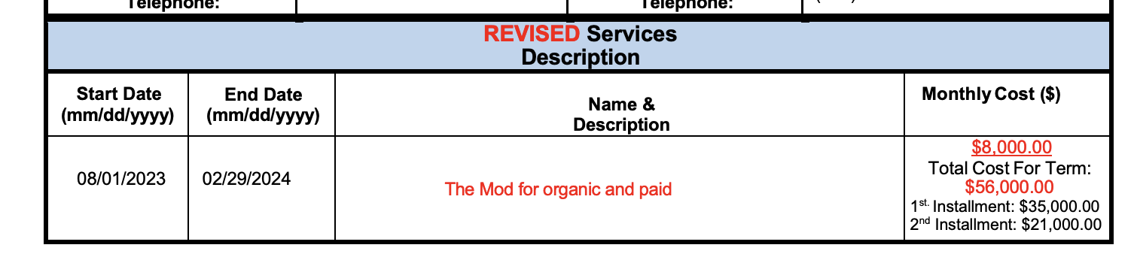

* 1. Customer/sub-customer
     1. Sometimes in contracts, there is a customer/sub-customer relationship outlined in the contracts. If they need to be billed separately, this should be outlined in the contrats, such as in the example below.
     2. If sub-customers need to be billed separately, the workflow is as follows:
        1. Download the contract and re-upload to merchant app (if 3 billable entities, do this twice)

**\*\*** [**GS Suri**](mailto:gssuri@tabsplatform.com)**to complete this flow**

* + - 1. If the customers already exists, assign new contracts to identified sub-customers in contract
      2. If this is a new contract, a new customer and/or sub–customer will need to be generated. The customer will be identified at the top of the contract where it says “Client Name”. The sub-customers will be outlined in the Campaign Details section as well as an additional section below outlining which BTs should go with which customer or sub-customer. [Follow this SOP for sub-customer creation](https://docs.google.com/document/d/1A6k7muER26bH6Csa9MrzOab7nLqaNAYG32fDfbOmKCs/edit?usp=sharing)
  1. Merchant Processing Instructions:
     1. For contracts associated with “Tottenham Hotspur Football & Athletic Co LTD” use Customer name “Tottenham Hotspur Football & Athletic Co LTD” **NOT** “Do Not Use Tottenham Hotspur Football & Athletic co Ltd (Deleted)”

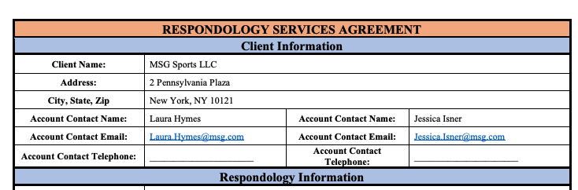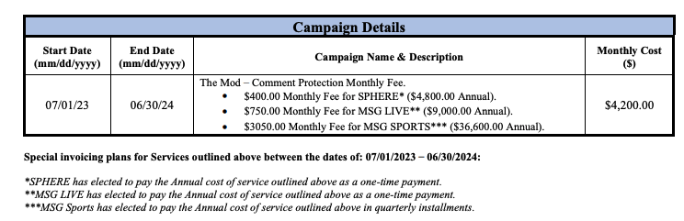

1. Anything to ignore in contracts?
   1. If a longer description shows in a 2nd paragraph below the first line of title/short description, then do not include (example below)

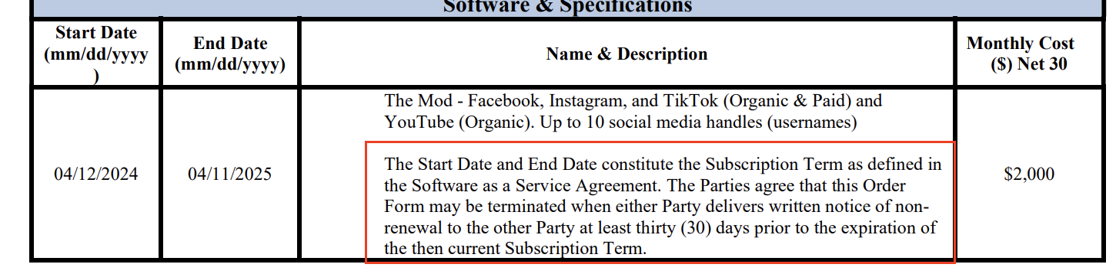

* 1. Another example below of a longer description with legal jargon - in this case use “**The Mod**” at the title and no description.

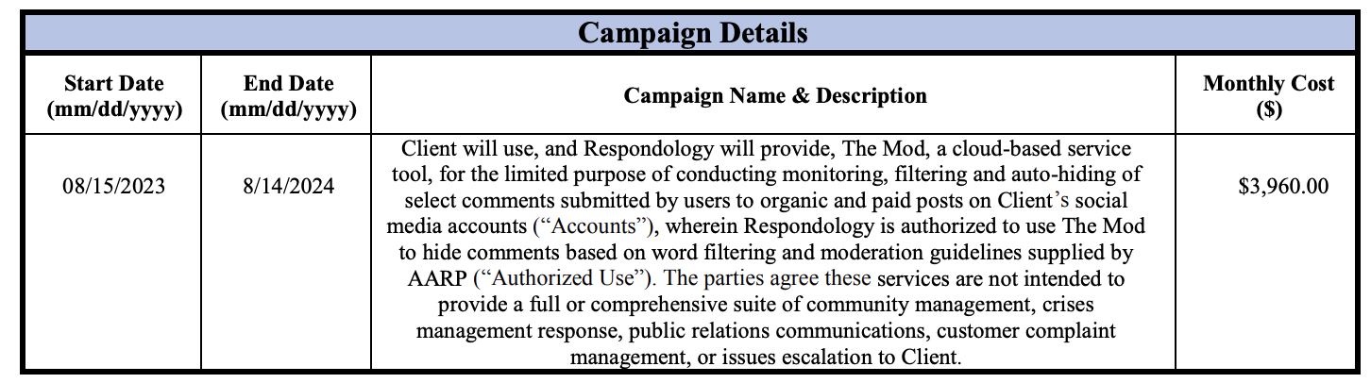

* 1. **Ignore** this box is seen on contracts:

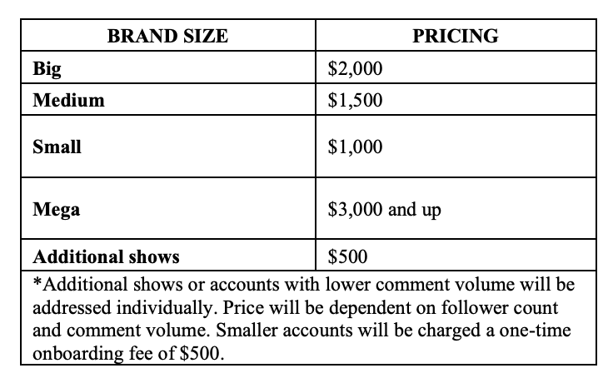

1. Specifics processing things merchant has requested that may differ by contract
   1. none
2. Default Start Date
   1. If start date says “TBD”, default to signature date
3. Default Service Term
   1. If end date is not identified and stated as “recurring”, default to 1 year
4. Default Net Payment Terms
   1. If None, Ops Default is 30
5. Default Billing Frequency
   1. If None Listed, default is Monthly
6. How do we handle taxes as a line item?
   1. If None Listed, Ops Default is every tax line item becomes a BT

### Events Processing (if necessary)

* There are a few current contracts that require usage, and they come in a couple of different forms

1. Media Spend Percentage (customer: Basis)
   1. This will be one usage based Billing term that will calculate the percentage of the total they submit for usage data.
   2. Name: Media Spend Fees
   3. Unit Price
   4. Total Price: Only use first tier percentage, not second
      1. Example below would be 0.012
   5. Event: Media Spend Percentage

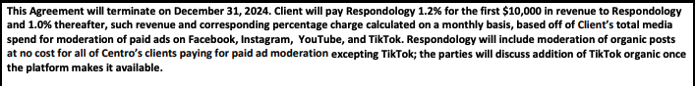

1. Tier based (customers: Influential and Valasis)
   1. This will be a tiered based usage model that it outlined in the contract
   2. Name: Either Paid Social Campaign or Influencer Campaign (for these two examples
   3. Integration Item: The Mod - Campaign
   4. Tiered flat
   5. KEY THING TO NOTE: There is a database flag that is needed for these types of terms that is enabled by the end team. This flag allows for line items on the usage csv to enter directly into the correct tier instead of graduating up to the tier. IF THIS IS SEEN FOR ANY NEW CONTRACTS, PLEASE FLAG TO ENG TEAM TO ENABLE THIS.
   6. Example of how this is laid out and should be processed is below:

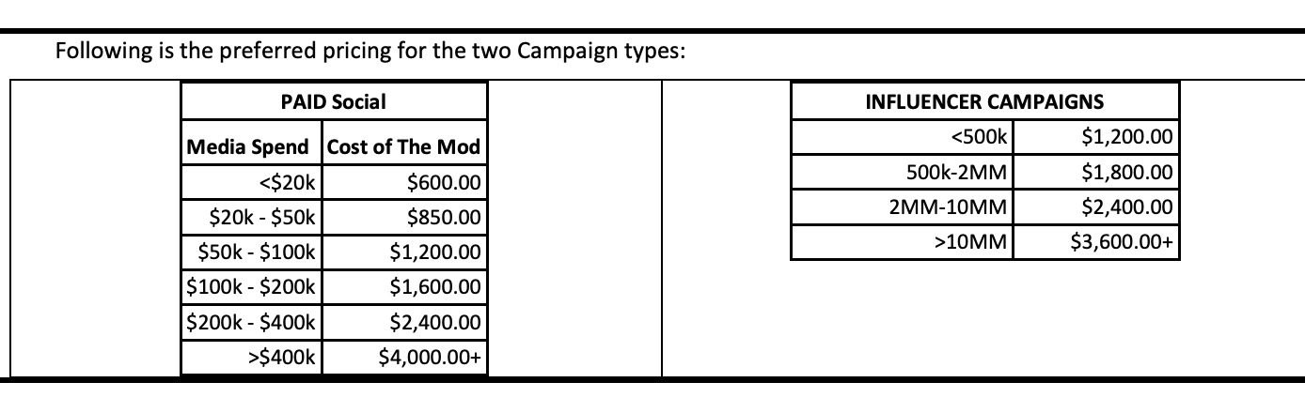

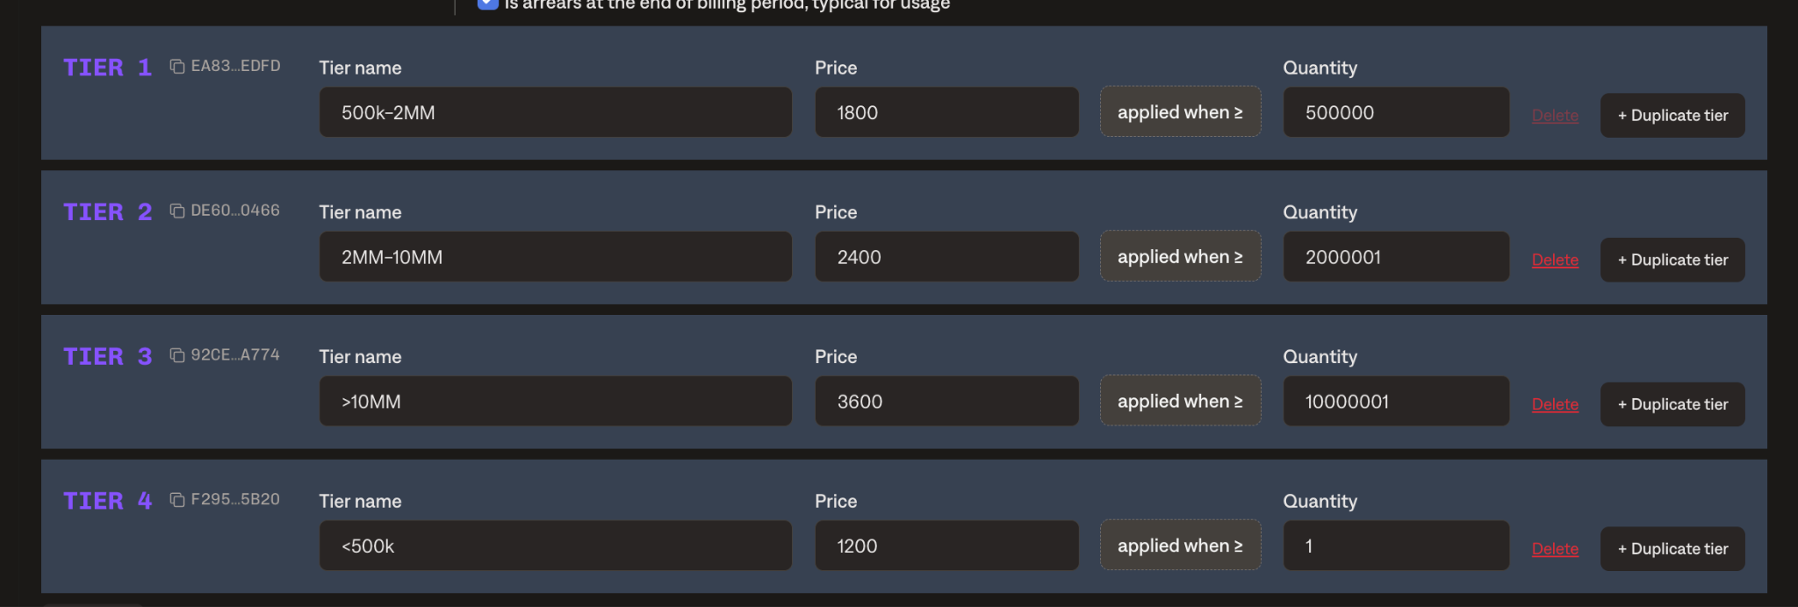

Integration Items Processing (if necessary)

* What are the instructions for assigning integration items?
  + **Mod Monthly subscription** is standard - **default for all**

Post Processing Communications (if necessary)

* Does Ops Team need to notify anyone on the team re: completion of processing batches in Implementation or Active phase?
  + none
* Who needs to be notified and when?
  + none

### Customer Information

* Any important information on specifics customers of this merchant
  + none

### Feature Requests

* FR 1

### Rewatch Calls

* May 22nd, 2024 Disco Call
  + https://tabs.rewatch.com/video/qe5fvv9flgj39gl0-izzy-nick-tabs-intro-may-22-2024
* June 5th, 2024 Custom Demo
  + <https://tabs.rewatch.com/video/gb9geauoh8k0ac2k-respondology-tabs-custom-demo-june-5-2024>
* June 21st,2024 Sync with Izzy
  + <https://tabs.rewatch.com/video/1k9v35kurzpcrnwb-izzy-nick-quick-sync-june-21-2024>